**MINI - PROJECT REPORT**

ON

**“The Lazy Script”**

**TE COMPUTER ENGINEERING**

IN

**NETWORK PROGRAMMING LABORATORY**

Submitted by

**15CO12- ( Ansari M Saeem M Saleem Farzana )**

**15CO13 - ( Ansari Mohammad Kurban Abdul Kayyum Sajma )**

**15CO15 - ( Chougle Zaid Noornabi Zerin )**

Course Owner

**( SHAIKH ABDUL SALAM )**



**Department of Computer Engineering,**

**School of Engineering & Technology**

**Anjuman-I-Islam’s Kalsekar Technical Campus**

Plot no 2 & 3, Sector - 16, Near Thana Naka, Khandagaon,

New Panvel, Navi Mumbai - 410206

**Academic Year : 2017-18**

**1. Design Layput**

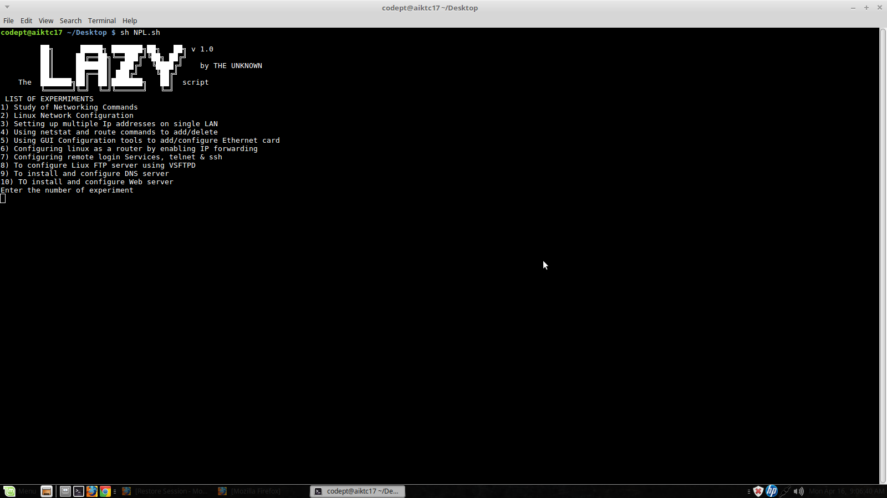

**2.Features / Modules**

